**Create UDF (User Defined Functions) in Apache Pig and execute it in**

**MapReduce/HDFS mode**

**AIM:**

To create UDF (User Defined Functions) in Apache Pig and execute it in MapReduce/HDFS mode.

**PROCEDURE:**

1. Ensure that Apache Pig is installed and configured.

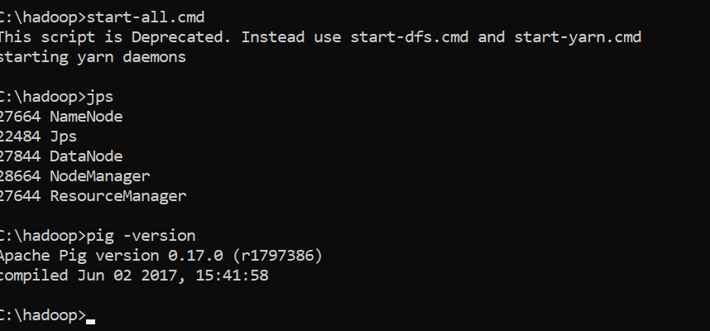

1. Create a python UDF (User Defined Functions).

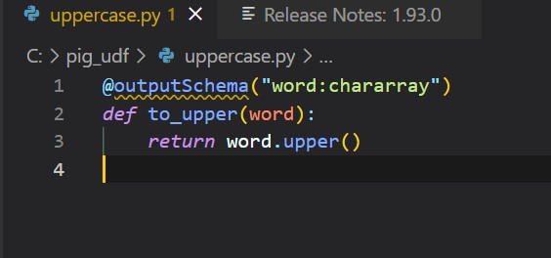

1. Jython should be installed as Pig will use it to interpret the Python UDFs.
2. Create a Pig script that registers and uses the Python UDF.

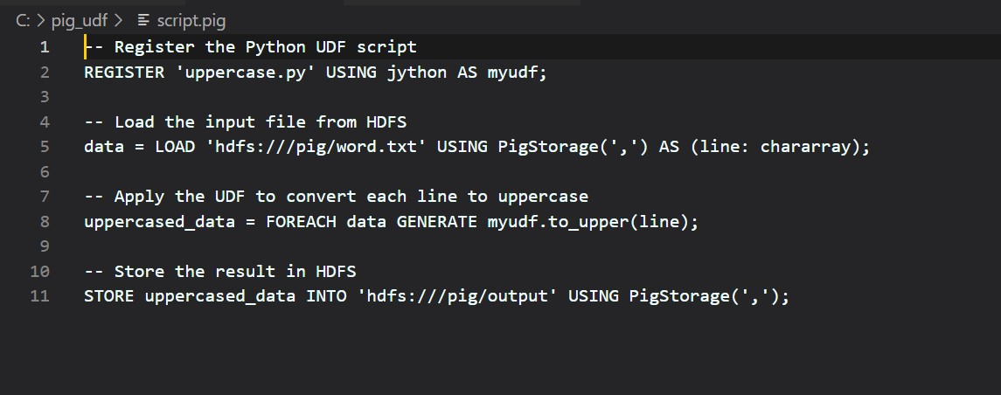

1. Execute the Pig Script in MapReduce Mode using the command: pig -x mapreduce script.pig

**OUTPUT:**

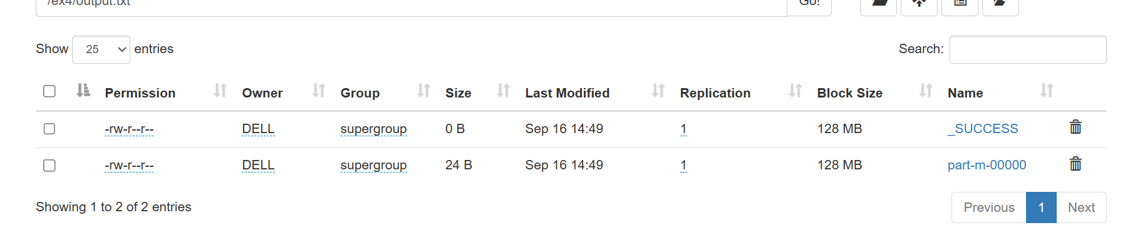

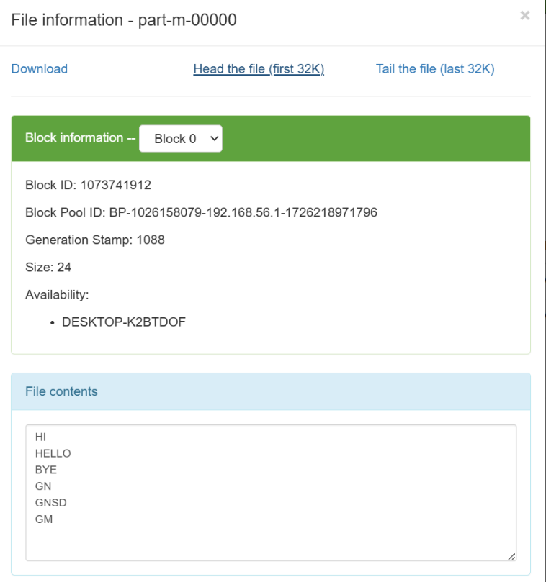

**RESULT:**

Thus, to create a UDF in Apache Pig and execute in MapReduce mdoe has been executed successfully